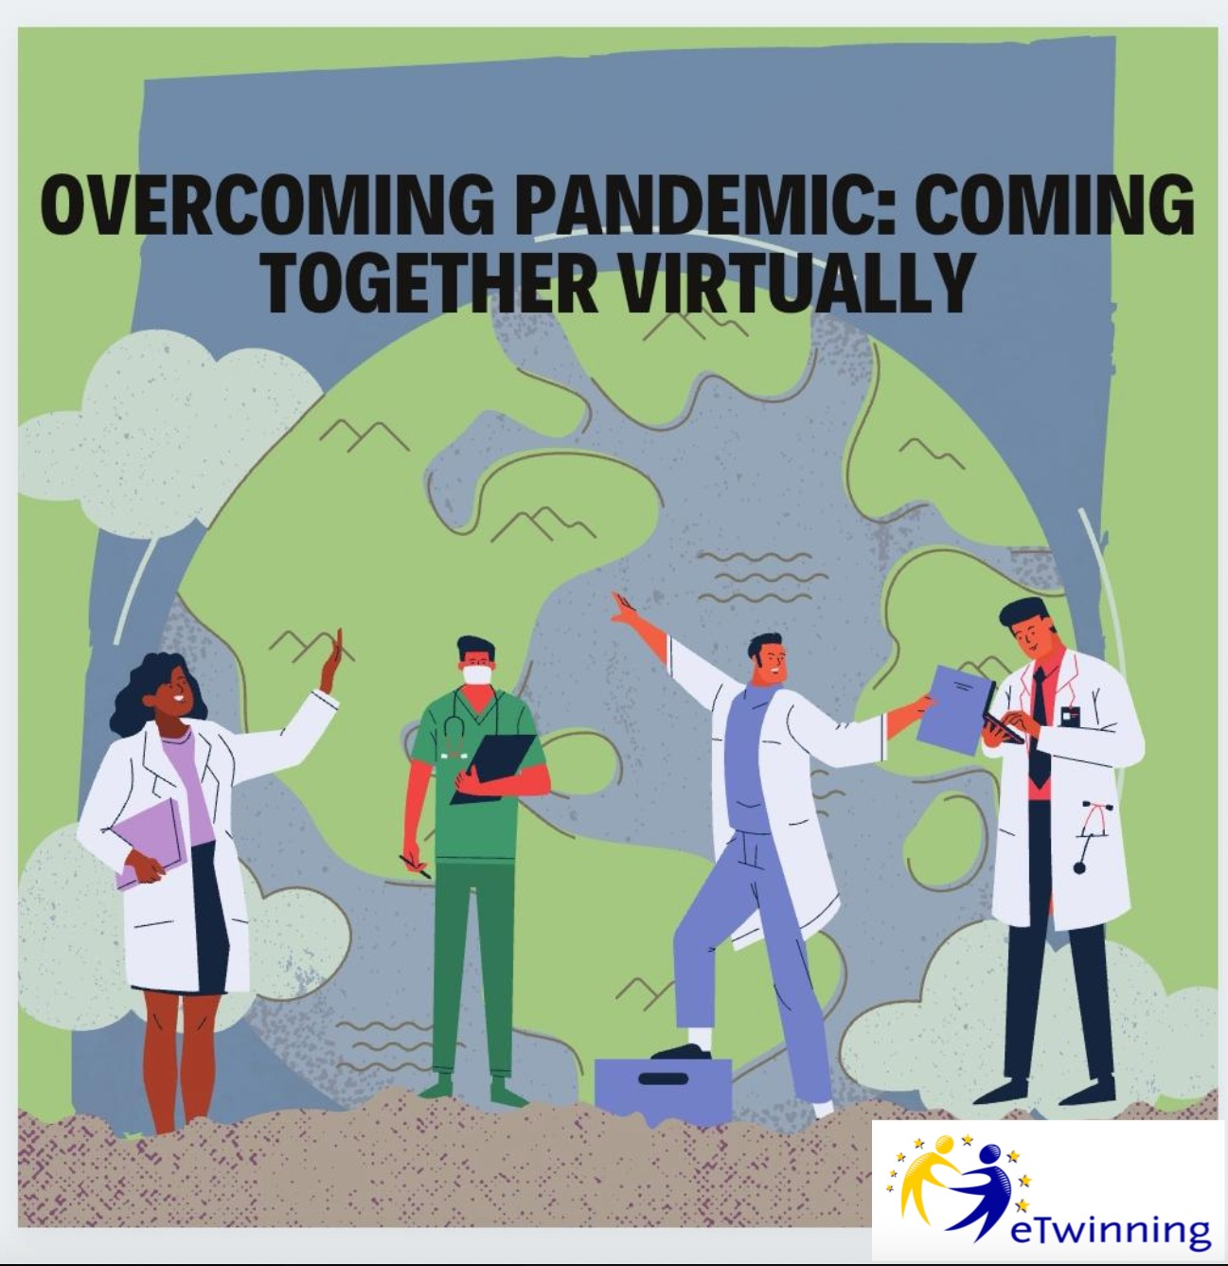

Pre-Survey Report

Overcoming Pandemic: Coming Together Virtually

The pre-survey prepared for our project includes 2 sections: “Project Experience and Attitude” and “Covid19 Past and Experience”. There are 6 questions in the first section and 19 questions in the latte making 25 questions in total.

The results can also be seen as graphics with the link below:
https://docs.google.com/forms/d/1EiYSwnHFw4d0vEXBAvObkEF8qxft66TPMzq0gE9YFnA/edit#responses

Section 1: Project Experience and Attitude

Firstly, the questions in this section aims to see how balanced we have been in creating our project teams. It turns out that the majority of the participants are new to both European Union projects and its tools while there is also a group who had experience in international projects. In the process of applying for the project, we believed in the efficiency of having mixed groups. So it is pleasing to see the results in accordance. In addition to this, the other questions in this section show us that we are working with an eager group in this project. They are all interested in meeting new people, new cultures and using new digital tools. We hope their experience and positive attitude towards international projects will be increased at the end of the project.

Section 2: Covid19 Past and Experience

In this section, there are questions about 5 different topics: Covid19 experience, Boredom and Loneliness, Physical Exercise and Nutrition Habits, Bullying and Distance Learning.

The results show that a minority has been infected with Covid19 so far. On the other hand, most of the students experienced lockdown or quarantine.

Two third of the participants feel mentally affected in a negative way because of the pandemic. Only one third of the participants think that they have been able to cope with these negative emotions.

Coming to the nutrition questions, the answers are balanced for this item. a 40% disagrees that their eating habits changed negatively while %30 agrees that it changed negatively. We hope this project will increase the motivation of the disagreeing group with the help of the agreeing one. On the other hand, almost half of the students are shown to have stated that they have been less physically active since the beginning of the pandemic which underlines the importance of showing and discussing ways to encourage the participants to be more active at home.

In terms of bullying, a great majority have never experienced bullying and never bullied anyone. We believe this can be a result of being socially isolated and protected from bullying. However, there are also a couple of students who experienced bullying.

The results show that the majority of the participants have been educated by means of distance learning. Most of them have the necessary equipment for distance learning which shows that distance learning is an undeniable part of today’s education. However, the results show that 42% of the students are not pleased with distance learning. Coming to their opinions to improve the quality of distance learning, 75% of the students believe that the responsibility is on the students. Besides, 65% disagrees with the idea that the problems in distance learning are caused by the teachers.

Finally, the items checking the students’ attitude towards coping with the negative effects of pandemic and the motivation to overcome these show that a great majority (almost 90%) has a positive attitude.

In conclusion, the results in general are supporting the aims of the project. As we work on each theme together, we expect to observe the increased awareness and motivation of our students. At the same time, the results show that the aims of our project are real and necessary for the teenagers experiencing Coronavirus pandemic.

